Machine Learning Tools that are Used in Medicine Box Alert System:
1. Google ML kit OCR (Optical Character Recognition):
Reason of Use: This ML used to recognize characters and extract data from the prescription. This is pre trained model exercised on millions of images of text (including printed text, and skewed angles) to instantly recognize letters and numbers. The benefit of this ML is it works entirely on offline, is incredibly fast, and ensures patient data privacy since the images are never sent to cloud to read.
2. Regex model: This model is used for decision making such as 1+0+1 convert this into Morning, Not Lunch, and Night medicine taking time. Besides, Getting the data for After meal and before meal tag. Furthermore, getting the medicine name from raw extracted data.
Making Improvements in this model:
3. Levenshtein Distance:

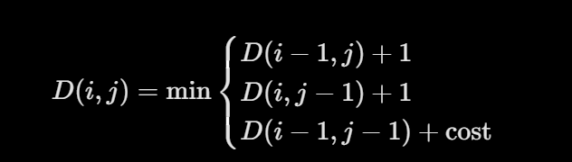

Medicine datasets Link:
1. https://github.com/lsiddiqsunny/API-for-Bangladeshi-Medicine
2.

